Context Data Flow Diagram

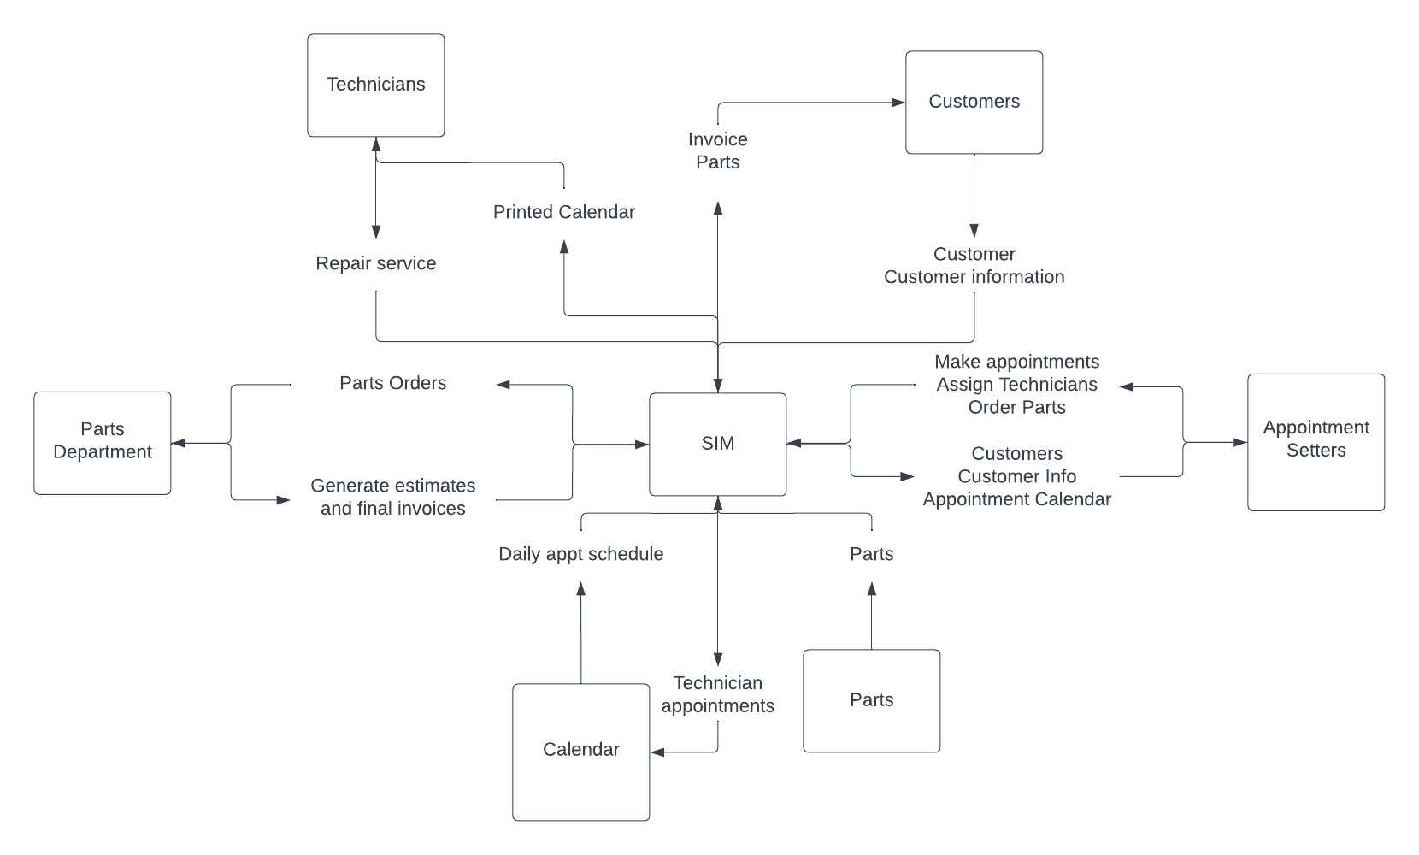

Decision table

|  |  |  |  |  |  |  |
| --- | --- | --- | --- | --- | --- | --- |
| **Decision Table** | **Rule 1** | **Rule 2** | **Rule 3** | **Rule 4** | **Rule 5** | **Rule 6** |
| **Condition** |  |  |  |  |  |  |
| Purchased appliance from AW | Y | Y | Y | Y | N | N |
| Purchased service plan | Y | Y | N | N | - | N |
| Serviced > 3 times a year | Y | N | N | - | - | N |
|  |  |  |  |  |  |  |
| **Actions** |  |  |  |  |  |  |
| No service fee only parts cost | FALSE | TRUE | FALSE | FALSE | FALSE | FALSE |
| 20% service fee discount | FALSE | FALSE | TRUE | TRUE | FALSE | FALSE |
| Full cost of service fee and parts | TRUE | FALSE | FALSE | FALSE | FALSE | FALSE |
| Full price of service plan and parts cost | FALSE | FALSE | FALSE | FALSE | TRUE | TRUE |

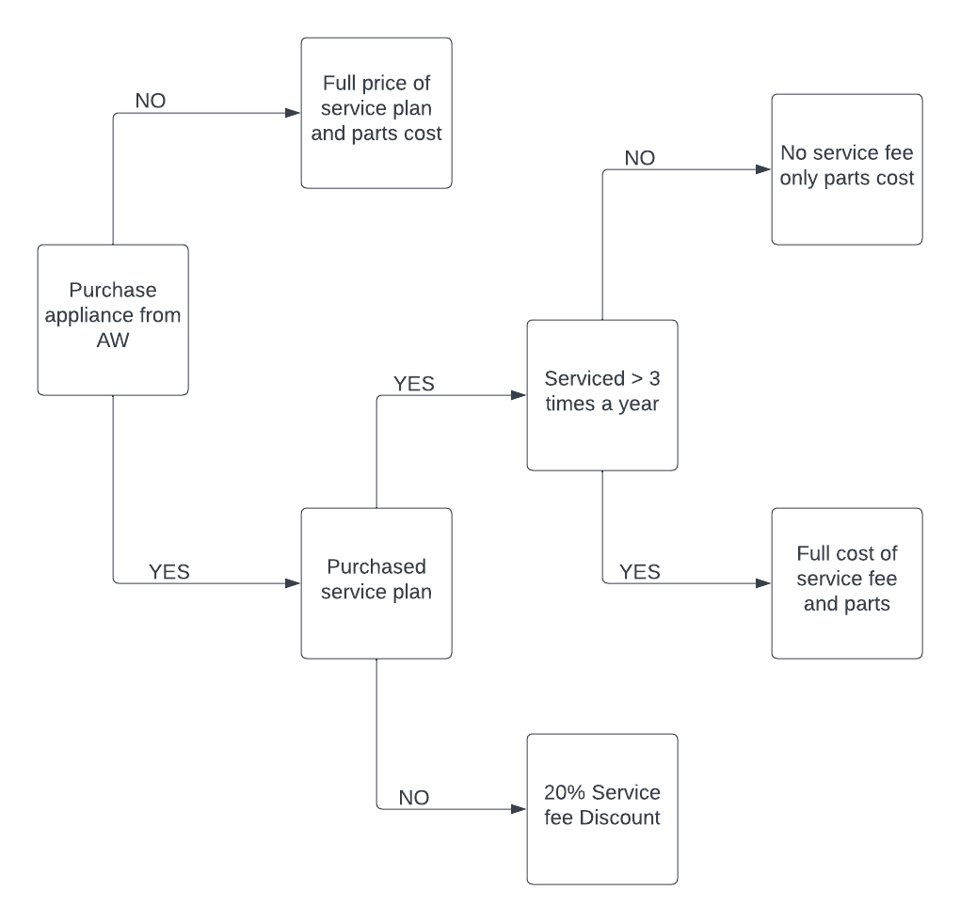Decision Tree